**How to set up the tool:**

1. Have Python3, VSCode installed.
2. Redirect to the location where the project must be placed. Download the file in this location.
3. Install the required packages by running “**pip install PackageName”**.
4. Once all the packages are installed. Run “**python app.py**”.

Once the tool is up and running, we get:

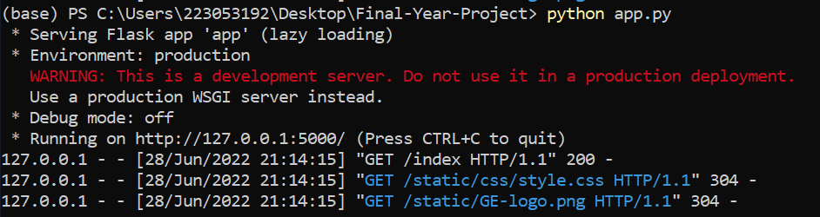

1. Hit <http://localhost:5000/index> in any browser. Upload the file, select the attribute, and hit submit.

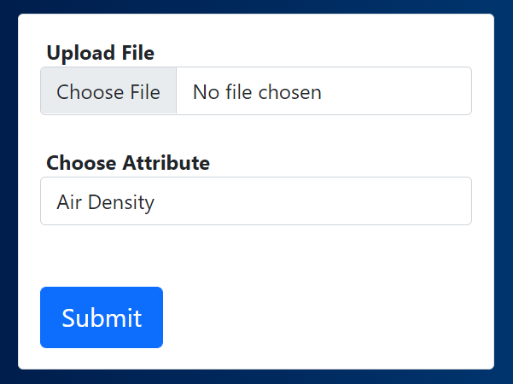

1. Once the comparisons are done, we get

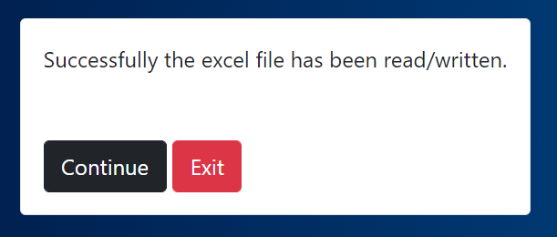

Now the user can continue with comparing other attribute values or can exit and the excel files can be opened to view the discrepancy list.